UNITED STATES
SECURITIES AND EXCHANGE COMMISSION
Washington, D.C. 20549
FORM 8-K
CURRENT REPORT
Pursuant to Section 13 or 15(d)
of the Securities Exchange Act of 1934
Date of Report (Date of earliest event reported): August 12, 2026
ITG, Inc.
(Exact name of registrant as specified in its charter)
Delaware |  |  | 001-43381 |  |  | 30-1479306
(State or other jurisdiction  of incorporation) |  |  | (Commission  File Number) |  |  | (I.R.S. Employer  Identification No.)
2400 E Commercial Blvd Ste 1000
Fort Lauderdale, FL 33308
(Address of Principal Executive Offices) (Zip code)
Registrant’s telephone number, including area code: (615) 447-5347
Check the appropriate box below if the Form 8-K filing is intended to simultaneously satisfy the filing obligation of the registrant under any of the following provisions:
☐ |  |  | Written communications pursuant to Rule 425 under the Securities Act (17 CFR 230.425)
☐ |  |  | Soliciting material pursuant to Rule 14a-12 under the Exchange Act (17 CFR 240.14a-12)
☐ |  |  | Pre-commencement communications pursuant to Rule 14d-2(b) under the Exchange Act (17 CFR 240.14d-2(b))
☐ |  |  | Pre-commencement communications pursuant to Rule 13e-4(c) under the Exchange Act (17 CFR 240.13e-4(c))
Securities registered pursuant to Section 12(b) of the Act:
Title of each class |  |  |  |  |  | Trading  Symbol(s) |  |  |  |  |  | Name of each exchange  on which registered
Class A common stock, par value $0.001 per share |  |  |  |  |  | ITG |  |  |  |  |  | The Nasdaq Stock Market LLC
Indicate by check mark whether the registrant is an emerging growth company as defined in Rule 405 of the Securities Act of 1933 (§230.405 of this chapter) or Rule 12b-2 of the Securities Exchange Act of 1934 (§240.12b-2 of this chapter).
Emerging growth company ☒
If an emerging growth company, indicate by check mark if the registrant has elected not to use the extended transition period for complying with any new or revised financial accounting standards provided pursuant to Section 13(a) of the Exchange Act. ☒

Item 2.02 Results of Operations and Financial Condition.
On August 12, 2026, ITG, Inc. issued a press release announcing its financial results for its second fiscal quarter ended June 30, 2026.
A copy of such press release is attached as Exhibit 99.1 and incorporated herein by reference. A reconciliation of certain non-GAAP financial measures to their comparable GAAP financial measures is contained in the press release.
This information shall not be deemed “filed” for purposes of Section 18 of the Securities Exchange Act of 1934, as amended (the “Exchange Act”), or incorporated by reference in any filing under the Securities Act of 1933, as amended, or the Exchange Act, except as shall be expressly set forth by specific reference in such a filing.

Item 9.01 Financial Statements and Exhibits.
(d) Exhibits.
Exhibit  Number |  |  |  |  |  | Description
99.1 |  |  |  |  |  | Press release dated August 12, 2026 by ITG, Inc. reporting fiscal 2026 second quarter results.
99.2 |  |  |  |  |  | Shareholder letter issued to accompany the Earnings Release under exhibit 99.1 which adds operational and financial commentary related to the reporting period.
104 |  |  |  |  |  | Cover Page Interactive Data File (embedded within the Inline XBRL document).

SIGNATURES
Pursuant to the requirements of the Securities Exchange Act of 1934, the registrant has duly caused this report to be signed on its behalf by the undersigned hereunto duly authorized.
 |  |  | ITG, INC.
Date: August 12, 2026 |  |  | By: |  |  | /s/ Andrew D. Parrott
 |  |  | Name: |  |  | Andrew D. Parrott
 |  |  | Title: |  |  | Chief Executive Officer

2
 |  |  | SECOND QUARTER 2026 EARNINGS RELEASE  August 12, 2026

ITG, Inc. Reports Second Quarter 2026 Results
Strong performance reflects continued momentum across ITG's scaled national platform, driven by continued strong demand for digital infrastructure services coupled with successful execution; initial 2026 outlook1 reflects ~35% revenue and ~36% Adjusted EBITDA growth
SECOND QUARTER 2026 HIGHLIGHTS
•Revenue increased 38% year-over-year to $404.6 million
•Net Income of $1.8 million
•Adjusted EBITDA2 increased 21% year-over-year to $52.2 million
•Free Cash Flow2 increased 66% year-over-year to $44.8 million
•NTM Backlog3 of $1,517 million as of June 30, 2026, compared to $1,259 million as of June 30, 2025 and $1,430 million as of March 31, 2026, supporting strong revenue visibility
•Strong order activity, including significant broadband fiber deployment awards with customers such as Ziply Fiber and Intrepid Fiber Networks
•Completed initial public offering subsequent to quarter end; net proceeds primarily applied to debt repayment
•Record levels in the quarter for revenue, Adjusted EBITDA and NTM Backlog
FORT LAUDERDALE, Fla., August 12, 2026 (GLOBE NEWSWIRE) – ITG, Inc. (Nasdaq: ITG) (“ITG or "the Company”), a leading provider of end-to-end services to the digital infrastructure industry, today announced financial results for its second quarter ended June 30, 2026.
ITG supports the planning, design, construction, operation, maintenance, and expansion of broadband, wireless, data center, utility, and civil infrastructure. ITG’s operating model spans both recurring maintenance and fulfillment activity and larger infrastructure deployment projects, enabling it to support customers across the lifecycle of network build, upgrade, and ongoing operations. With a workforce operating across 49 states, ITG is positioned to build and maintain the digital backbone powering the future.

"Our second quarter results reflect continued momentum across the business and strong execution of our growth strategy," said Andy Parrott, Chief Executive Officer of ITG. "Performance was driven by contributions from recent acquisitions, expansion of existing and new customer programs, increased activity under recently awarded contracts, and supported by broadly favorable demand trends. Growth was generated from both our Engineering & Maintenance and Infrastructure Deployment service lines, reflecting continued investment in network maintenance, upgrades, and deployment activity.”

"The completion of our initial public offering marked an important milestone for ITG. We entered the public markets with a scaled national platform and significant revenue visibility, supported by a strong backlog and long-standing customer relationships. This positions us well to capitalize on favorable digital infrastructure investment trends expected in coming years, including the national build-out of data center capacity,” Mr. Parrott noted. “We believe our differentiated operating model, national workforce and proprietary FUSE360 technology platform strengthen our competitive position and supports our ability to execute consistently at scale.”
1.Statements related to our initial full-year 2026 financial outlook are forward-looking, and actual results may differ materially. Refer to the “Forward Looking Statements” in the Appendix of this document for information on the factors that could cause our actual results to differ materially from these forward-looking statements.
2.Non-GAAP measure – Refer to the Appendix of this document for definitions of non-GAAP measures, reconciliations of these measures to the most directly comparable U.S. GAAP measure and a discussion of why management believes these non-GAAP measures are useful. As discussed below, ITG is not providing reconciliations of forward-looking non-GAAP measures because such reconciliations are not available without unreasonable effort.
3.Next Twelve Month (NTM) Backlog represents total committed future revenue over the next twelve months supported by executed contracts, historical activity levels, customer guidance, and / or management estimates. Timing for revenue from projects included in NTM Backlog is subject to change based on a number of factors. Actual results may differ materially.
SECOND QUARTER 2026 EARNINGS RELEASE
August 12, 2026

Mr. Parrott concluded, "We remain focused on executing for our customers, investing in our workforce and fleet, and pursuing strategic opportunities that enhance our capabilities and market presence. We are pleased to introduce our initial 2026 financial outlook, reflecting our confidence in the opportunities ahead."
2026 FINANCIAL OUTLOOK1
(in millions, except margin, effective tax rate, CapEx, and shares outstanding)
 |  |  | Q3 2026 |  |  | YoY Growth2 |  |  | FY 2026 |  |  | YoY Growth2
Revenue |  |  | $440 |  |  | +42% |  |  | $1,556 |  |  | +35%
Adjusted Net Income3 |  |  | $31 |  |  | +239% |  |  | $74 |  |  | +80%
Adjusted EBITDA3 |  |  | $63 |  |  | +61% |  |  | $202 |  |  | +36%
Adjusted EBITDA Margin3 |  |  | 14.4% |  |  | +170 bps |  |  | 13.0% |  |  | +20 bps
Forecast Assumptions
Effective Tax Rate |  |  |  |  |  |  |  |  | ~19%
CapEx (% of Revenue) |  |  |  |  |  |  |  |  | ~2.6%
Net Interest Expense |  |  |  |  |  |  |  |  | ~$62
Depreciation Expense |  |  |  |  |  |  |  |  | ~$52
Amortization Expense |  |  |  |  |  |  |  |  | ~$32
Diluted Shares Outstanding |  |  |  |  |  |  |  |  | ~124.4
1.Statements related to our initial full-year 2026 financial outlook are forward-looking, and actual results may differ materially. Refer to the “Forward Looking Statements” in the Appendix of this document for information on the factors that could cause our actual results to differ materially from these forward-looking statements.
2.Represents year-over-year growth compared to the prior year period. “Bps” represents basis points of change on percentage data.
3.Non-GAAP measures – Refer to the Appendix of this document for definitions of non-GAAP measures, reconciliations of these measures to the most directly comparable U.S. GAAP measure and a discussion of why management believes these non-GAAP measures are useful. As discussed below, ITG is not providing reconciliations of forward-looking non-GAAP measures because such reconciliations are not available without unreasonable effort.

SECOND QUARTER 2026 COMMENTARY
ITG has posted its Second Quarter 2026 Commentary on the Investors section of ITG’s website at ir.itgcomm.com. This document provides detailed commentary on ITG's second quarter 2026 financial and operating performance, business trends and outlook and should be reviewed in conjunction with the earnings release and conference call.
CONFERENCE CALL INFORMATION
ITG will host a webcast of its quarterly earnings call to discuss these results on Thursday, August 13, 2026, at 8:00 a.m. ET, which can be accessed through the Investors section of ITG’s website at ir.itgcomm.com. A replay of the webcast also will be available following the live event.

SECOND QUARTER 2026 EARNINGS RELEASE
August 12, 2026

ABOUT ITG, INC.
ITG is a leading provider of end-to-end services to the communications and digital infrastructure industries throughout the United States. ITG supports the planning, design, construction, operation, maintenance, and expansion of broadband, wireless, data center, utility, and civil infrastructure. With a workforce operating across 49 states, ITG is positioned to build and maintain the digital backbone powering our future.

SECOND QUARTER 2026 EARNINGS RELEASE
August 12, 2026

APPENDIX
Forward Looking Statements
This press release contains forward-looking statements within the meaning of the Private Securities Litigation Reform Act of 1995 that are based on our management’s beliefs and assumptions and on information currently available to our management. These statements include, but are not limited to, statements regarding our expectations of future performance, including guidance for our revenue, Adjusted Net Income, Adjusted EBITDA and Adjusted EBITDA Margin for the fiscal year ending December 31, 2026, and our NTM Backlog as of June 30, 2026. Forward-looking statements can be identified by terms such as “anticipate”, “believe”, “could”, “estimate”, “expect”, “intend”, “may”, “plan”, “potential”, “predict”, “project”, “seek”, “should”, “will”, “would” or similar expressions and the negatives of those terms. Such statements are not historical facts but rather are based on the Company’s current expectations or beliefs concerning future events. Forward-looking statements involve known and unknown risks, uncertainties and other factors, that may cause our actual results to be materially different from any future results contemplated by the forward-looking statements, including those described in the registration statements and periodic reports the Company files with the Securities and Exchange Commission (the “SEC”), including the Company’s final prospectus dated June 30, 2026 and filed with the SEC on July 2, 2026. Given these uncertainties, you should not place undue reliance on forward-looking statements. Any forward-looking statement speaks only as of the date on which it was made, and the Company does not undertake any obligation to update or revise any forward-looking statement, whether as a result of new information, future events or otherwise, except as required by law. When considering these forward-looking statements, you should keep in mind the risk factors and other cautionary statements in the Company’s registration statements and periodic reports.
Non-GAAP Financial Measures
This press release includes certain financial measures that are not calculated in accordance with generally accepted accounting principles in the United States (“GAAP”), including Adjusted EBITDA, Adjusted EBITDA Margin, Adjusted Net Income, Adjusted EPS and Free Cash Flow. Management uses these non-GAAP financial measures to evaluate the Company’s operating performance, cash generation, liquidity, leverage profile and ability to execute its strategic priorities. The Company believes these measures provide useful supplemental information to investors in evaluating period-to-period operating performance and financial position.
Non-GAAP financial measures should not be considered in isolation from, or as a substitute for, financial information presented in accordance with GAAP. These measures may not be comparable to similarly titled measures used by other companies. Reconciliations of each non-GAAP financial measure to the most directly comparable GAAP financial measure are provided below.
The Company is providing guidance for certain non-GAAP financial measures, including Adjusted EBITDA, Adjusted EBITDA Margin and Free Cash Flow. The Company is not providing quantitative reconciliations of these forward-looking non-GAAP measures to the most directly comparable GAAP measures due to the uncertainty and inherent difficulty of predicting certain items that affect GAAP results, including, as applicable, acquisition-related costs, stock-based compensation, changes in working capital, interest expense, depreciation and amortization, tax impacts, and other items that may be material and difficult to forecast. Accordingly, a reconciliation is not available without unreasonable effort. The variability of these items could have a significant impact on the Company’s future GAAP financial results.

SECOND QUARTER 2026 EARNINGS RELEASE
August 12, 2026

FINANCIAL STATEMENTS
ITG Parent, LLC
CONDENSED CONSOLIDATED STATEMENTS OF OPERATIONS (Unaudited)
(in thousands, except per unit amount)
 |  |  | Three Months Ended  June 30, |  |  |  |  |  |  |  |  |  |  |  | Six Months Ended  June 30,
 |  |  | 2026 |  |  |  |  |  | 2025 |  |  |  |  |  | 2026 |  |  |  |  |  | 2025
Revenue |  |  | $ | 404,633 |  |  |  |  | $ | 292,405 |  |  |  |  | $ | 738,555 |  |  |  |  | $ | 517,792
Cost of revenue, excluding depreciation and amortization |  |  | 332,581 |  |  |  |  |  | 237,091 |  |  |  |  |  | 613,647 |  |  |  |  |  | 423,696
Selling, general and administrative |  |  | 28,141 |  |  |  |  |  | 15,765 |  |  |  |  |  | 53,713 |  |  |  |  |  | 30,546
Depreciation and amortization |  |  | 21,014 |  |  |  |  |  | 13,988 |  |  |  |  |  | 41,439 |  |  |  |  |  | 27,245
Change in fair value of contingent liabilities |  |  | 300 |  |  |  |  |  | 170 |  |  |  |  |  | 2,186 |  |  |  |  |  | 337
Total |  |  | 382,036 |  |  |  |  |  | 267,014 |  |  |  |  |  | 710,985 |  |  |  |  |  | 481,824
Interest expense |  |  | (19,534) |  |  |  |  |  | (6,919) |  |  |  |  |  | (37,759) |  |  |  |  |  | (13,745)
Other expense, net |  |  | (1,008) |  |  |  |  |  | (1,042) |  |  |  |  |  | (1,927) |  |  |  |  |  | (2,030)
Income (loss) before provision for income taxes |  |  | 2,055 |  |  |  |  |  | 17,430 |  |  |  |  |  | (12,116) |  |  |  |  |  | 20,193
Provision (benefit) for income taxes |  |  | 267 |  |  |  |  |  | 5,829 |  |  |  |  |  | (746) |  |  |  |  |  | 7,013
Net income (loss) |  |  | $ | 1,788 |  |  |  |  | $ | 11,601 |  |  |  |  | $ | (11,370) |  |  |  |  | $ | 13,180
Earnings (loss) per unit – Class A
Basic and diluted |  |  | $ | 0.01 |  |  |  |  | $ | 0.07 |  |  |  |  | $ | (0.07) |  |  |  |  | $ | 0.08
Weighted average number of units – Class A
Basic and Diluted |  |  | 160,000 |  |  |  |  |  | 160,000 |  |  |  |  |  | 160,000 |  |  |  |  |  | 160,000

SECOND QUARTER 2026 EARNINGS RELEASE
August 12, 2026

ITG Parent, LLC
CONDENSED CONSOLIDATED BALANCE SHEETS (Unaudited)
(in thousands)
 |  |  | June 30, 2026 |  |  |  |  |  | December 31, 2025
ASSETS
Current assets
Cash and cash equivalents |  |  | $ | 2,486 |  |  |  |  | $ | 3,719
Accounts receivable, net |  |  | 148,855 |  |  |  |  |  | 141,314
Contract assets |  |  | 309,825 |  |  |  |  |  | 222,094
Prepaid expenses and other current assets |  |  | 23,855 |  |  |  |  |  | 17,310
Total current assets |  |  | 485,021 |  |  |  |  |  | 384,437
Property and equipment, net |  |  | 161,300 |  |  |  |  |  | 158,492
Operating lease right-of-use assets |  |  | 28,107 |  |  |  |  |  | 27,926
Finance lease right-of-use assets |  |  | 2,375 |  |  |  |  |  | 3,019
Goodwill |  |  | 189,193 |  |  |  |  |  | 187,748
Intangible assets, net |  |  | 194,888 |  |  |  |  |  | 211,383
Other long-term assets |  |  | 4,894 |  |  |  |  |  | —
Due from related party |  |  | 2,832 |  |  |  |  |  | 2,832
Total assets |  |  | $ | 1,068,610 |  |  |  |  | $ | 975,837
LIABILITIES AND MEMBERS’ EQUITY
Current liabilities
Accounts payable |  |  | $ | 65,136 |  |  |  |  | $ | 41,221
Accrued expenses |  |  | 57,456 |  |  |  |  |  | 57,245
Current portion of operating lease obligations |  |  | 11,183 |  |  |  |  |  | 10,969
Current portion of finance lease obligations |  |  | 1,264 |  |  |  |  |  | 1,221
Current portion of equipment loans |  |  | 21,588 |  |  |  |  |  | 22,493
Current portion of term loans |  |  | 16,500 |  |  |  |  |  | 16,500
Total current liabilities |  |  | 173,127 |  |  |  |  |  | 149,649
Equipment loans, net |  |  | 76,746 |  |  |  |  |  | 65,804
Revolving line of credit |  |  | 112,000 |  |  |  |  |  | 30,000
Term loans, net |  |  | 617,167 |  |  |  |  |  | 623,463
Operating lease obligations, net |  |  | 17,581 |  |  |  |  |  | 17,608
Finance lease obligations, net |  |  | 1,250 |  |  |  |  |  | 1,905
Other long-term liabilities |  |  | 2,831 |  |  |  |  |  | 7,100
Contingent liabilities |  |  | 17,836 |  |  |  |  |  | 20,088
Deferred tax liability |  |  | 15,696 |  |  |  |  |  | 16,475
Total liabilities |  |  | 1,034,234 |  |  |  |  |  | 932,092
Commitments and contingencies
Members’ equity |  |  | 34,376 |  |  |  |  |  | 43,745
Total liabilities and members’ equity |  |  | $ | 1,068,610 |  |  |  |  | $ | 975,837

SECOND QUARTER 2026 EARNINGS RELEASE
August 12, 2026

ITG Parent, LLC
CONDENSED CONSOLIDATED STATEMENTS OF CASH FLOWS (Unaudited)
(in thousands)
Six Months Ended
June 30,
 |  |  | 2026 |  |  |  |  |  | 2025
Cash flows from operating activities:
Net (loss) income |  |  | (11,370) |  |  |  |  |  | 13,180
Adjustments to reconcile net (loss) income to net cash (used in) provided by operating activities:
Depreciation |  |  | 24,944 |  |  |  |  |  | 12,942
Amortization of intangible assets |  |  | 16,495 |  |  |  |  |  | 14,303
Amortization of debt issuance costs |  |  | 2,429 |  |  |  |  |  | 605
Amortization of operating right of use assets |  |  | 8,672 |  |  |  |  |  | 3,955
Deferred income taxes |  |  | (779) |  |  |  |  |  | (2,823)
Loss (gain) on sale of assets |  |  | 85 |  |  |  |  |  | (66)
Change in fair value of contingent liabilities |  |  | 2,186 |  |  |  |  |  | 337
Equity-based compensation |  |  | 2,339 |  |  |  |  |  | 1,270
Changes in assets and liabilities, net of business acquisitions:
Accounts receivable |  |  | (6,228) |  |  |  |  |  | (12,940)
Contract assets |  |  | (87,731) |  |  |  |  |  | (7,297)
Prepaid expenses and other current assets |  |  | (7,019) |  |  |  |  |  | 428
Accounts payable and accrued expenses |  |  | 19,979 |  |  |  |  |  | (8,293)
Operating lease liabilities |  |  | (8,022) |  |  |  |  |  | (3,856)
Payments of contingent liabilities |  |  | (3,022) |  |  |  |  |  | —
Net cash (used in) provided by operating activities |  |  | (47,042) |  |  |  |  |  | 11,745
Cash flows from investing activities:
Purchase of property and equipment |  |  | (15,969) |  |  |  |  |  | (28,627)
Proceeds from sale of property and equipment |  |  | 1,225 |  |  |  |  |  | 1,239
Acquisitions, net of cash acquired |  |  | (3,440) |  |  |  |  |  | (8,448)
Net cash used in investing activities |  |  | (18,184) |  |  |  |  |  | (35,836)
Cash flows from financing activities:
Payments of acquisition amounts due to sellers |  |  | (5,891) |  |  |  |  |  | —
Payments of contingent liabilities |  |  | (1,416) |  |  |  |  |  | —
Payments made on term loans |  |  | (8,251) |  |  |  |  |  | (11,812)
Proceeds from line of credit |  |  | 373,000 |  |  |  |  |  | 67,000
Payments made on line of credit |  |  | (291,000) |  |  |  |  |  | (53,500)
Payments on finance leases |  |  | (612) |  |  |  |  |  | —
Distributions to members |  |  | (338) |  |  |  |  |  | —
Proceeds from equipment loans |  |  | 11,332 |  |  |  |  |  | 22,279
Payments made on equipment loans |  |  | (12,831) |  |  |  |  |  | (6,135)
Payments of debt costs |  |  | — |  |  |  |  |  | (262)
Net cash provided by financing activities |  |  | 63,993 |  |  |  |  |  | 17,570
NET DECREASE IN CASH AND CASH EQUIVALENTS |  |  | (1,233) |  |  |  |  |  | (6,521)
Cash and cash equivalents – beginning of period |  |  | 3,719 |  |  |  |  |  | 7,367
Cash and cash equivalents – end of period |  |  | $ | 2,486 |  |  |  |  | $ | 846

SECOND QUARTER 2026 EARNINGS RELEASE
August 12, 2026

Non-GAAP Financial Measures & Reconciliations
Adjusted EBITDA and Free Cash Flow Reconciliation
The following table reconciles net income, the most directly comparable financial measure presented in accordance with GAAP, to Adjusted EBITDA and Free Cash Flow, and calculations of Adjusted EBITDA Margin and Free Cash Flow Conversion for the three and six months ended June 30, 2026 and 2025:
 |  |  | ITG Parent, LLC
 |  |  | For the Three Months  Ended June 30, |  |  |  |  |  |  |  |  |  |  |  | For the Six Months  Ended June 30,
 |  |  | 2026 |  |  |  |  |  | 2025 |  |  |  |  |  | 2026 |  |  |  |  |  | 2025
(in thousands, except for percentages)
Net income (loss) |  |  | $ | 1,788 |  |  |  |  | $ | 11,601 |  |  |  |  | $ | (11,370) |  |  |  |  | $ | 13,180
Interest expense |  |  | 19,534 |  |  |  |  |  | 6,919 |  |  |  |  |  | 37,759 |  |  |  |  |  | 13,745
Income tax expense (benefit) |  |  | 267 |  |  |  |  |  | 5,829 |  |  |  |  |  | (746) |  |  |  |  |  | 7,013
Depreciation expense |  |  | 12,766 |  |  |  |  |  | 6,787 |  |  |  |  |  | 24,944 |  |  |  |  |  | 12,942
Amortization of intangibles |  |  | 8,248 |  |  |  |  |  | 7,201 |  |  |  |  |  | 16,495 |  |  |  |  |  | 14,303
Other expense, net |  |  | 1,008 |  |  |  |  |  | 1,042 |  |  |  |  |  | 1,927 |  |  |  |  |  | 2,030
Equity-based compensation |  |  | 1,170 |  |  |  |  |  | 625 |  |  |  |  |  | 2,339 |  |  |  |  |  | 1,270
Transaction costs(1) |  |  | 1,907 |  |  |  |  |  | 714 |  |  |  |  |  | 3,365 |  |  |  |  |  | 1,620
Restructuring, integration, and business optimization costs(2) |  |  | 5,206 |  |  |  |  |  | 2,460 |  |  |  |  |  | 11,516 |  |  |  |  |  | 4,317
Change in fair value of contingent liabilities(3) |  |  | 300 |  |  |  |  |  | 170 |  |  |  |  |  | 2,186 |  |  |  |  |  | 337
Adjusted EBITDA |  |  | $ | 52,194 |  |  |  |  | $ | 43,348 |  |  |  |  | $ | 88,415 |  |  |  |  | $ | 70,757
Adjusted EBITDA Margin |  |  | 12.9% |  |  |  |  |  | 14.8% |  |  |  |  |  | 12.0% |  |  |  |  |  | 13.7%
Purchase of property and equipment |  |  | $ | 7,440 |  |  |  |  | $ | 16,163 |  |  |  |  | $ | 15,969 |  |  |  |  | $ | 28,627
Free Cash Flow |  |  | $ | 44,754 |  |  |  |  | $ | 27,185 |  |  |  |  | $ | 72,446 |  |  |  |  | $ | 42,130
Free Cash Flow Conversion |  |  | 85.7% |  |  |  |  |  | 62.7% |  |  |  |  |  | 81.9% |  |  |  |  |  | 59.5%
(1)Represents professional, legal and advisory fees incurred in connection with acquisitions completed during the presented period.
(2)Represents non-recurring expenses associated with the restructuring of management positions, start-up costs for new markets and service offerings and exiting locations that we do not expect will impact the go forward operations of the business.
(3)Represents non-recurring earnout amounts accrued to certain sellers in connection with the acquisitions completed during the presented period.

SECOND QUARTER 2026 EARNINGS RELEASE
August 12, 2026

INVESTOR CONTACT
629-282-9862
ir@itgcomm.com

 |  |  | SECOND QUARTER 2026 COMMENTARY  August 12, 2026

This Commentary supplements ITG Inc.'s ("ITG" or the "Company") earnings release, providing additional commentary on our financial performance, operating trends, customer activity, backlog and cash flow, capital allocation priorities, and outlook. Please refer to the Appendix for cautionary statements regarding forward-looking statements, definitions of non-GAAP financial measures, and reconciliations of these measures to the most directly comparable U.S. GAAP measures.
SECOND QUARTER HIGHLIGHTS
•Revenue increased 38% year-over-year to $404.6 million
•Net Income of $1.8 million
•Adjusted EBITDA1 increased 21% year-over-year to $52.2 million
•Free Cash Flow1 increased 66% year-over-year to $44.8 million
•NTM Backlog2 of $1,517 million as of June 30, 2026, compared to $1,259 million as of June 30, 2025 and $1,430 million as of March 31, 2026, supporting strong revenue visibility
•Strong order activity and customer momentum, including significant broadband fiber deployment awards with customers such as Ziply Fiber and Intrepid Fiber Networks
•Completed initial public offering subsequent to quarter end; net proceeds primarily applied to debt repayment
•Record levels in the quarter for revenue, Adjusted EBITDA and NTM Backlog
FINANCIAL HIGHLIGHTS
(in millions, except for margins)
 |  |  | Q2 2026 |  |  | Q2 2025 |  |  | YoY % |  |  | YTD 2026 |  |  | YTD 2025 |  |  | YoY %
Consolidated Revenue |  |  | $404.6 |  |  | $292.4 |  |  | 38.4% |  |  | $738.6 |  |  | $517.8 |  |  | 42.6%
Engineering & Maintenance |  |  | $239.4 |  |  | $164.4 |  |  | 45.6% |  |  | $451.1 |  |  | $303.9 |  |  | 48.4%
Infrastructure Deployment |  |  | $165.2 |  |  | $128.0 |  |  | 29.1% |  |  | $287.5 |  |  | $213.9 |  |  | 34.4%
Net Income |  |  | $1.8 |  |  | $11.6 |  |  | (84.6)% |  |  | ($11.4) |  |  | $13.2 |  |  | NM
Adjusted Net Income1 |  |  | $13.6 |  |  | $17.6 |  |  | (24.9)% |  |  | $23.1 |  |  | $26.2 |  |  | (12.0)%
Adjusted EBITDA1 |  |  | $52.2 |  |  | $43.3 |  |  | 21.2% |  |  | $88.4 |  |  | $70.8 |  |  | 25.4%
Adjusted EBITDA Margin1 |  |  | 12.9% |  |  | 14.8% |  |  | - |  |  | 12.0% |  |  | 13.7% |  |  | -
Free Cash Flow1 |  |  | $44.8 |  |  | $27.2 |  |  | 66.3% |  |  | $72.4 |  |  | $42.1 |  |  | 73.1%
1.Non-GAAP measure – Refer to the Appendix of this document for definitions of non-GAAP measures, reconciliations of these measures to the most directly comparable U.S. GAAP measure and a discussion of why management believes these non-GAAP measures are useful. As discussed below, ITG is not providing reconciliations of forward-looking non-GAAP measures because such reconciliations are not available without unreasonable effort.
2.Next Twelve Month (NTM) Backlog represents total committed future revenue over the next twelve months supported by executed contracts, historical activity levels, customer guidance, and / or management estimates. Timing for revenue from projects included in NTM Backlog is subject to change based on a number of factors. Actual results may differ materially.

SECOND QUARTER 2026 COMMENTARY
August 12, 2026

EXECUTIVE SUMMARY
As we report our first earnings results following the completion of our initial public offering in July, we begin an exciting new chapter for ITG. Over the last decade, we have built a scaled national platform serving digital infrastructure customers across the United States. This is supported by long-standing customer relationships and a proven track record of disciplined and profitable growth. We have a clear strategy focused on expanding customer relationships, broadening service capabilities, and growing in attractive adjacent markets while leveraging our technology, scale and operational excellence to create long-term shareholder value.
Second quarter results reflected continued momentum across the business. Consolidated revenue increased 38% year-over-year led by new and existing customers and program expansions across the business. Recent acquisitions also contributed to growth and expanded ITG’s capabilities and geographic reach. Growth was supported by continued customer investment in network maintenance, upgrades and deployment activity. Rapidly emerging opportunities in data center connectivity and adjacent infrastructure markets also contributed through initial project work won over the last year.

ITG is well-positioned to leverage positive demand trends through its long-standing customer relationships, end-to-end service capabilities, and national scaled workforce. ITG can support customers across the digital infrastructure lifecycle, expanding from an initial service offering to a broad suite of capabilities.

A key differentiator and growth enabler for ITG is our proprietary technology platform FUSE360, a business operations and intelligence technology platform that enhances customer connectivity, supports rapid workforce onboarding and mobilization, accelerates acquisition integration and helps our operators execute consistently across a national footprint. The platform supports the coordination of ITG’s direct employees as well as its subcontractor network, increasing visibility across project execution and other workflows. As customers increasingly look to consolidate work with larger and more capable providers, we believe our FUSE360 technology, coupled with workforce scale and operational discipline, strengthens our overall competitive position.

ITG enters the second half of 2026 with strong customer relationships, a substantial backlog, a recurring revenue base, and a strong balance sheet. We remain focused on disciplined execution, prudent capital allocation and delivering sustainable long-term growth by expanding our share with existing customers and applying our technology and national platform to win new business across digital infrastructure markets.

SECOND QUARTER 2026 COMMENTARY
August 12, 2026

SECOND QUARTER 2026 RESULTS & COMMENTARY
Consolidated Revenues & Margins
(in millions, except for margins)
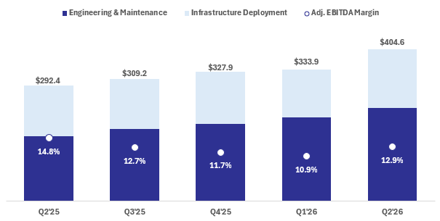
Revenue increased 38% year-over-year to $404.6 million in the second quarter, reflecting continued strength across ITG's digital infrastructure markets. Growth was supported by increased activity across recurring maintenance programs and infrastructure deployment projects, including expansion with existing customers, new customer wins and new program activity. Contributions from recent acquisitions provided an additional source of growth and expanded ITG’s service capabilities and geographic presence. Demand remained well supported by continued customer investment in broadband, network upgrades, maintenance requirements and growing investment in data center build-outs and related connectivity.
Adjusted EBITDA increased 21% year-over-year to $52.2 million, driven by increased revenue volumes and continued sound execution across the business, while also reflecting investments to support future growth, including workforce expansion, operational infrastructure and public company readiness.
Adjusted EBITDA margin of 12.9% in the second quarter improved approximately 200 basis points sequentially from 10.9% in the first quarter and was 14.8% in the prior year quarter. The sequential improvement primarily reflected the seasonal increase in volumes, which supported stronger workforce utilization and improved fixed operating cost absorption.

Compared with the prior-year period, Adjusted EBITDA margin declined primarily due to startup costs associated with onboarding and mobilizing employees and subcontractors, deploying fleet and equipment, establishing local operating infrastructure and preparing new programs for customer launch. The year-over-year comparison also reflected mix changes related to acquisitions completed in the second half of 2025 and investments in public-company readiness. Management expects the start-up and integration-related items to moderate through the balance of the year as new operations mature and acquisition contributions normalize, supporting the margin trajectory embedded in ITG’s outlook.
ITG remains focused on leveraging scale, improving labor utilization in target markets, maintaining pricing discipline and utilizing FUSE360 to enhance visibility and operating performance.

SECOND QUARTER 2026 COMMENTARY
August 12, 2026

Engineering & Maintenance Overview

Engineering & Maintenance ("E&M") provides recurring fulfillment, maintenance, engineering, design, consulting and network-support services that help customers maintain, upgrade and expand critical communications and digital infrastructure. E&M generally consists of a high volume of "small ticket" recurring service activity supported by long-term customer relationships and master service agreements (MSAs). ITG’s geographic density, workforce scale and FUSE360 platform enables us to coordinate these activities efficiently across direct employees and subcontractors.

Engineering & Maintenance (E&M) Revenue
(in millions)
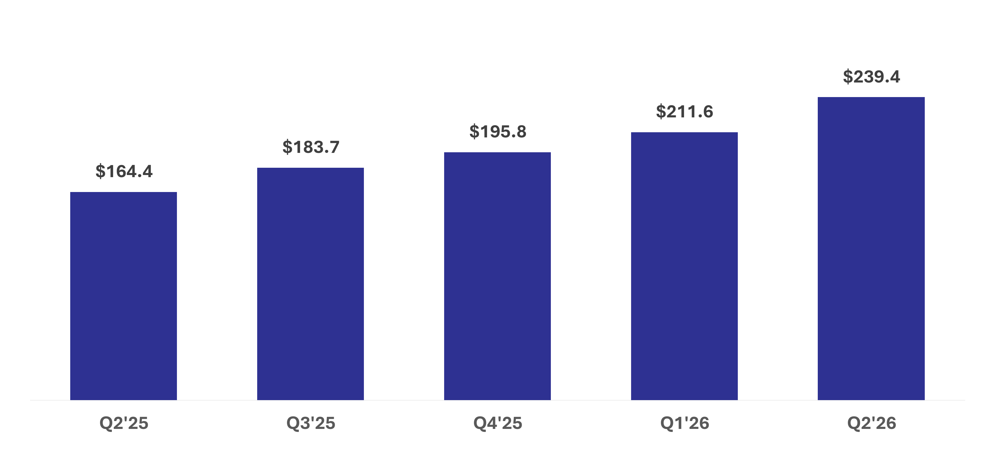
Revenue within the Engineering & Maintenance service line increased 46% year-over-year to $239.4 million. Growth was supported by increased activity with existing customers across recurring fulfillment, maintenance, engineering and network-support programs, together with new customer wins and program expansions. Acquisitions completed within the last year provided an additional contribution to growth.

Demand trends remain favorable entering the second half of the year. ITG is positioned to capture this demand through its established customer relationships, recurring service capabilities, local operating presence and ability to deploy resources consistently across multiple markets. ITG also seeks to expand its share of customer spending by introducing additional services into existing relationships and converting infrastructure deployment work into recurring engineering and maintenance opportunities. As network reliability, capacity and performance remain key customer priorities, management believes E&M remains well positioned to support continued customer growth while providing ITG a strong recurring revenue foundation.

SECOND QUARTER 2026 COMMENTARY
August 12, 2026

Infrastructure Deployment Overview

Infrastructure Deployment provides planning, construction and deployment services for broadband, fiber, wireless, data-center, utility and other digital infrastructure projects. The service line primarily supports larger network-expansion and connectivity programs, including fiber deployment and the infrastructure required to connect communities, networks and data-center facilities. ITG’s engineering capabilities, national workforce and end-to-end service model position the Company to execute complex projects across multiple geographies.

Infrastructure Deployment Revenue
(in millions)
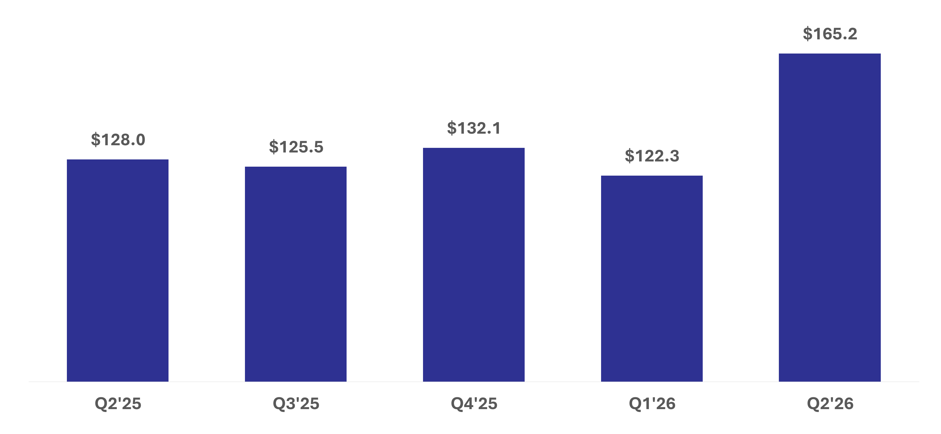
Revenue within the Infrastructure Deployment service line increased 29% year-over-year to $165.2 million. Core growth was supported by continued execution on fiber deployment, network expansion and broader communications and digital infrastructure programs, including activity with both existing and new customers. Acquisitions completed within the last year also contributed significantly to the year-over-year increase. Second-quarter revenue increased 35% sequentially, as project activity increased from the seasonally lower first quarter, and customers continued investments to expand network capacity and improve broadband performance. ITG saw an increase in activity with data-center customers on project awards already in backlog and expects to see additional sequential pickup in this activity in the second half of 2026 including contribution from new programs that start around mid-year.

ITG continues to see a supportive backdrop in demand for broadband expansion, data-center connectivity and adjacent digital infrastructure markets. The Company seeks to leverage this opportunity via its engineering capabilities, national operating footprint, customer relationships and ability to provide services across the full project lifecycle. The Company’s end-to-end service model and engineering capabilities position it well to compete for larger and increasingly complex programs.

ITG operates a pull-through model under which an initial deployment engagement can create opportunities to provide ongoing engineering, maintenance and network-support services after construction is completed. This model enables ITG to expand customer relationships across service lines and has been a key differentiator over time.

SECOND QUARTER 2026 COMMENTARY
August 12, 2026

Consolidated Next Twelve Months (NTM) Backlog1
(in millions)
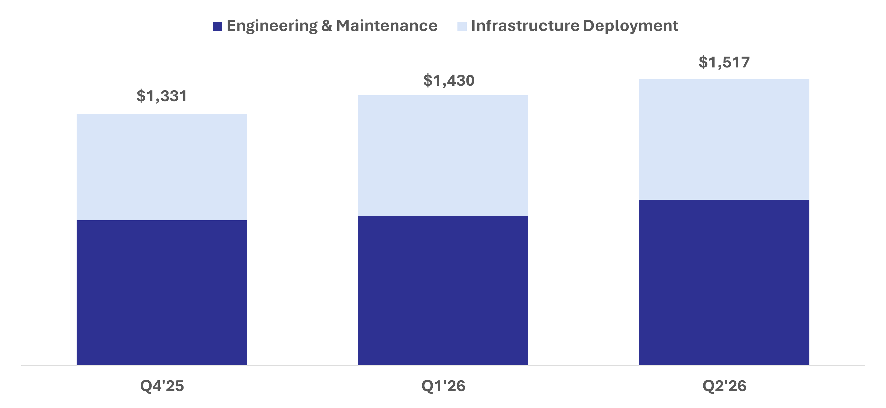
1.Next Twelve Month (NTM) Backlog represents total committed future revenue over the next twelve months supported by executed contracts, historical activity levels, customer guidance, and / or management estimates. Timing for revenue from projects included in NTM Backlog is subject to change based on a number of factors. Actual results may differ materially.

NTM Backlog remained robust entering the second half of 2026, reflecting continued customer investment across digital infrastructure markets and providing solid visibility into future expected revenue. ITG's overall visibility is supported by a combination of multi-year project activity (primarily in the Infrastructure Deployment service line) and a significant recurring revenue base (underlying the E&M service line) generated under long-term customer MSAs, creating a diversified and durable foundation for growth.
ITG continued to win significant new work across existing and new programs during the second quarter. New awards included a significant expansion of fiber deployment commitments from Ziply Fiber as well as incremental commitments from Intrepid Fiber Networks, Verizon and other new and existing customers. These awards reflect both the expansion of established relationships and ITG’s ability to secure new work on larger broadband and network-deployment programs. Management believes the combination of backlog growth, recurring revenue streams, strong customer retention and expanding opportunities in adjacent markets supports confidence in ITG's outlook.

SECOND QUARTER 2026 COMMENTARY
August 12, 2026

Free Cash Flow 1
(in millions)

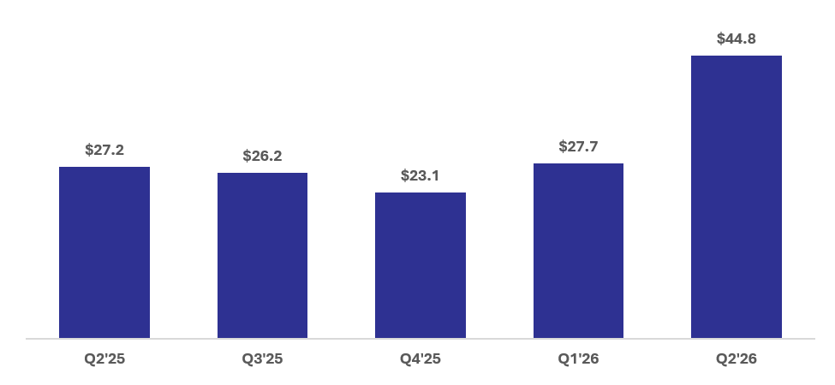
1.Free Cash Flow is defined as Adjusted EBITDA less capital expenditures
Free cash flow increased 66% year-over-year to $44.8 million in the second quarter, reflecting stronger earnings, improved operating performance and continued focus on working capital management. The increase demonstrates the benefits of scaling the business while maintaining disciplined capital deployment.
ITG remains focused on improving cash conversion as the business grows. FUSE360 provides enhanced operational visibility that supports billing and collections execution, while management continues to emphasize working capital discipline across the organization and believes that opportunity exists to reduce total receivables and contract asset days. Combined with a capital-efficient business model, these initiatives are expected to support strong free cash flow over time.
Working Capital: DSOs2 were 33 days in the second quarter, compared with 37 days in the first quarter of 2026 and 31 days in the second quarter of 2025. Contract asset days, including unbilled revenue, totaled 69 days in the second quarter, compared with 71 days in the first quarter of 2026 and 56 days in the second quarter of 2025.

The year-over-year increase in contract asset days reflects acquisitions completed primarily during 2025, as well as several new-business startups during the last year, which affected the mix and billing profiles of contracts. As these programs mature, management plans to continue to improve the timeliness of project documentation, billing and collections, supported by greater operating visibility through FUSE360, with the objective of reducing contract asset days.

2.Days Sales Outstanding ("DSO") is calculated based on the ending balance of Accounts receivable, net, divided by the average daily revenue for the most recently completed quarter.

SECOND QUARTER 2026 COMMENTARY
August 12, 2026

Balance Sheet & Liquidity
(in millions, except for leverage)
ITG’s initial public offering, as a subsequent event to the second quarter, significantly strengthened the balance sheet and enhanced financial flexibility. Proceeds from the offering were primarily used to repay outstanding borrowings under ITG's revolving credit facility and term loan, increasing available borrowing capacity and providing additional operating and strategic M&A flexibility.
Pro forma for the initial public offering, total liquidity increased from $66.7 million at quarter-end to approximately $165.5 million, consisting of $163.0 million of available revolver capacity and $2.5 million of cash. Combined with free cash flow generation, enhanced liquidity and a disciplined approach to capital allocation, ITG is well positioned to execute its growth strategy.
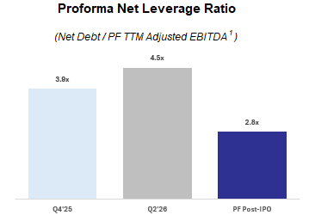
 |  |  | Q4'25 |  |  | Q2'26 |  |  | Pro Forma (Post-IPO)
Cash |  |  | $3.7 |  |  | $2.5 |  |  | $2.5
Revolving Credit Facility |  |  | $30.0 |  |  | $112.0 |  |  | $17.6
Equipment Loan |  |  | $88.3 |  |  | $98.3 |  |  | $98.3
Term Loan |  |  | $660.0 |  |  | $651.8 |  |  | $422.7
Total Debt |  |  | $778.3 |  |  | $862.1 |  |  | $538.6
Net Debt |  |  | $774.6 |  |  | $859.6 |  |  | $536.1
Liquidity |  |  | $158.7 |  |  | $66.7 |  |  | $165.5
Pro forma adjusted EBITDA includes adjustment permitted under the Company’s credit agreement for EBITDA from acquired businesses for periods prior to their respective acquisition dates, including Centerline beginning in 2024, Tilson beginning in Q4 2024, and all other acquisitions beginning in 2023

Capital Allocation Priorities
ITG's capital allocation strategy remains focused on creating long-term shareholder value primarily through disciplined growth investment in the existing business and by continuing to execute its M&A strategy. The Company will continue investing in workforce development, fleet expansion, technology capabilities and operational infrastructure necessary to support future growth needs.
M&A is an important component of ITG's growth strategy. The Company continues to evaluate opportunities that can expand existing customer relationships, enhance service capabilities, strengthen geographic density and increase exposure to attractive adjacent markets. At the same time, ITG remains committed to maintaining financial flexibility and a disciplined approach to capital deployment and use of financial leverage.
ITG completed its first acquisition post IPO on August 10, purchasing certain assets of a company in the digital broadband services space named Full Circle Fiber. Management is pleased to have completed this tuck-in transaction in a very short timeframe and expects the assets to contribute positively to ITG, including a rapid integration of their people, assets and contracts into the FUSE360 system.

SECOND QUARTER 2026 COMMENTARY
August 12, 2026

2026 FINANCIAL OUTLOOK1
ITG entered the second half of the year with strong backlog, favorable demand trends, long-standing customer relationships and a recurring revenue base supported by long-standing MSA agreements. Customer investment across digital infrastructure markets continues to create attractive opportunities for growth.
ITG is initiating financial guidance for 2026 and believes that substantial backlog conversion will deliver solid revenue, adjusted net income and adjusted EBITDA growth in the period, supported by visible drivers described above.
2026 Guidance
(in millions, except margin, effective tax rate, CapEx, and shares outstanding)
 |  |  | Q3 2026 |  |  | YoY Growth2 |  |  | FY 2026 |  |  | YoY Growth2
Revenue |  |  | $440 |  |  | +42% |  |  | $1,556 |  |  | +35%
Adjusted Net Income3 |  |  | $31 |  |  | +239% |  |  | $74 |  |  | +80%
Adjusted EBITDA3 |  |  | $63 |  |  | +61% |  |  | $202 |  |  | +36%
Adjusted EBITDA Margin3 |  |  | 14.4% |  |  | +170 bps |  |  | 13.0% |  |  | +20 bps
Forecast Assumptions
Effective Tax Rate (Post IPO) |  |  |  |  |  |  |  |  | ~19%
CapEx (% of Revenue) |  |  |  |  |  |  |  |  | ~2.6%
Net Interest Expense |  |  |  |  |  |  |  |  | ~$62
Depreciation Expense |  |  |  |  |  |  |  |  | ~$52
Amortization Expense |  |  |  |  |  |  |  |  | ~$32
Diluted Shares Outstanding |  |  |  |  |  |  |  |  | ~124.4
1.Statements related to our initial full-year 2026 financial outlook are forward-looking, and actual results may differ materially. Refer to the “Forward-Looking Statements” in the Appendix of this document for information on the factors that could cause our actual results to differ materially from these forward-looking statements.
2.Represents year-over-year growth compared to the prior year period. “Bps” represents basis points of change on percentage data.
3.Non-GAAP measures – Refer to the Appendix of this document for definitions of non-GAAP measures, reconciliations of these measures to the most directly comparable U.S. GAAP measure and a discussion of why management believes these non-GAAP measures are useful. As discussed below, ITG is not providing reconciliations of forward-looking non-GAAP measures because such reconciliations are not available without unreasonable effort.

SECOND QUARTER 2026 COMMENTARY
August 12, 2026

CONFERENCE CALL INFORMATION
ITG will host a webcast of its quarterly earnings call to discuss these results on Thursday, August 13, 2026, at 8:00 a.m. ET, which can be accessed through the Investors section of ITG’s website at ir.itgcomm.com. A replay of the webcast also will be available following the live event.
ABOUT ITG, INC.
ITG is a leading provider of end-to-end services to the communications and digital infrastructure industries throughout the United States. ITG supports the planning, design, construction, operation, maintenance, and expansion of broadband, wireless, data center, utility, and civil infrastructure. With a workforce operating across 49 states, ITG is positioned to build and maintain the digital backbone powering our future.
APPENDIX
Forward-Looking Statements
This Commentary contains forward-looking statements within the meaning of the Private Securities Litigation Reform Act of 1995 that are based on our management’s beliefs and assumptions and on information currently available to our management. These statements include, but are not limited to, statements regarding our expectations of future performance, including guidance for our revenue, Adjusted Net Income, Adjusted EBITDA and Adjusted EBITDA Margin for the third quarter ending September 30, 2026 and the fiscal year ending December 31, 2026, and our NTM Backlog as of June 30, 2026. Forward-looking statements can be identified by terms such as “anticipate”, “believe”, “could”, “estimate”, “expect”, “intend”, “may”, “plan”, “potential”, “predict”, “project”, “seek”, “should”, “will”, “would” or similar expressions and the negatives of those terms. Such statements are not historical facts but rather are based on the Company’s current expectations or beliefs concerning future events. Forward-looking statements involve known and unknown risks, uncertainties and other factors, that may cause our actual results, performance or achievements to be materially different from any future results, performance or achievements expressed or implied by the forward-looking statements, including those described in the registration statements and periodic reports the Company files with the Securities and Exchange Commission (the “SEC”), including the Company’s final prospectus dated June 30, 2026 and filed with the SEC on July 2, 2026. Given these uncertainties, you should not place undue reliance on forward-looking statements. Any forward-looking statement speaks only as of the date on which it was made, and the Company does not undertake any obligation to update or revise any forward-looking statement, whether as a result of new information, future events or otherwise, except as required by law. When considering these forward-looking statements, you should keep in mind the risk factors and other cautionary statements in the Company’s registration statements and periodic reports.
Non-GAAP Financial Measures
This Commentary includes certain financial measures that are not calculated in accordance with generally accepted accounting principles in the United States (“GAAP”), including Adjusted EBITDA, Adjusted EBITDA Margin, Adjusted Net Income, Free Cash Flow, Net Debt, Net Leverage Ratio and Total Liquidity. Management uses these non-GAAP financial measures to evaluate the Company’s operating performance, cash generation, liquidity, leverage profile and ability to execute its strategic priorities. The Company believes these measures provide useful supplemental information to investors in evaluating period-to-period operating performance and financial position.
Non-GAAP financial measures should not be considered in isolation from, or as a substitute for, financial information presented in accordance with GAAP. These measures may not be comparable to similarly titled

SECOND QUARTER 2026 COMMENTARY
August 12, 2026

measures used by other companies. Reconciliations of each non-GAAP financial measure to the most directly comparable GAAP financial measure are provided below.
The Company is providing guidance for certain non-GAAP financial measures, including Adjusted EBITDA, Adjusted EBITDA Margin and Free Cash Flow. The Company is not providing quantitative reconciliations of these forward-looking non-GAAP measures to the most directly comparable GAAP measures due to the uncertainty and inherent difficulty of predicting certain items that affect GAAP results, including, as applicable, acquisition-related costs, stock-based compensation, changes in working capital, interest expense, depreciation and amortization, tax impacts, and other items that may be material and difficult to forecast. Accordingly, a reconciliation is not available without unreasonable effort. The variability of these items could have a significant impact on the Company’s future GAAP financial results.
Non-GAAP Financial Measures & Reconciliations
The following table reconciles net income, the most directly comparable financial measure presented in accordance with GAAP, to Adjusted EBITDA and Free Cash Flow, and calculations of Adjusted EBITDA Margin and Free Cash Flow Conversion for the three and six months ended June 30, 2026 and 2025:
 |  |  | ITG Parent, LLC
 |  |  | For the Three Months  Ended June 30, |  |  |  |  |  |  |  |  |  |  |  | For the Six Months  Ended June 30,
 |  |  | 2026 |  |  |  |  |  | 2025 |  |  |  |  |  | 2026 |  |  |  |  |  | 2025
(in thousands, except for percentages)
Net income (loss) |  |  | $ | 1,788 |  |  |  |  | $ | 11,601 |  |  |  |  | $ | (11,370) |  |  |  |  | $ | 13,180
Interest expense |  |  | 19,534 |  |  |  |  |  | 6,919 |  |  |  |  |  | 37,759 |  |  |  |  |  | 13,745
Income tax expense (benefit) |  |  | 267 |  |  |  |  |  | 5,829 |  |  |  |  |  | (746) |  |  |  |  |  | 7,013
Depreciation expense |  |  | 12,766 |  |  |  |  |  | 6,787 |  |  |  |  |  | 24,944 |  |  |  |  |  | 12,942
Amortization of intangibles |  |  | 8,248 |  |  |  |  |  | 7,201 |  |  |  |  |  | 16,495 |  |  |  |  |  | 14,303
Other expense, net |  |  | 1,008 |  |  |  |  |  | 1,042 |  |  |  |  |  | 1,927 |  |  |  |  |  | 2,030
Equity-based compensation |  |  | 1,170 |  |  |  |  |  | 625 |  |  |  |  |  | 2,339 |  |  |  |  |  | 1,270
Transaction costs(1) |  |  | 1,907 |  |  |  |  |  | 714 |  |  |  |  |  | 3,365 |  |  |  |  |  | 1,620
Restructuring, integration, and business optimization costs(2) |  |  | 5,206 |  |  |  |  |  | 2,460 |  |  |  |  |  | 11,516 |  |  |  |  |  | 4,317
Change in fair value of contingent liabilities(3) |  |  | 300 |  |  |  |  |  | 170 |  |  |  |  |  | 2,186 |  |  |  |  |  | 337
Adjusted EBITDA |  |  | $ | 52,194 |  |  |  |  | $ | 43,348 |  |  |  |  | $ | 88,415 |  |  |  |  | $ | 70,757
Adjusted EBITDA Margin |  |  | 12.9% |  |  |  |  |  | 14.8% |  |  |  |  |  | 12.0% |  |  |  |  |  | 13.7%
Purchase of property and equipment |  |  | $ | 7,440 |  |  |  |  | $ | 16,163 |  |  |  |  | $ | 15,969 |  |  |  |  | $ | 28,627
Free Cash Flow |  |  | $ | 44,754 |  |  |  |  | $ | 27,185 |  |  |  |  | $ | 72,446 |  |  |  |  | $ | 42,130
Free Cash Flow Conversion |  |  | 85.7% |  |  |  |  |  | 62.7% |  |  |  |  |  | 81.9% |  |  |  |  |  | 59.5%
(1)Represents professional, legal and advisory fees incurred in connection with acquisitions completed during the presented period.
(2)Represents non-recurring expenses associated with the restructuring of management positions, start-up costs for new markets and service offerings and exiting locations that we do not expect will impact the go forward operations of the business.
(3)Represents non-recurring earnout amounts accrued to certain sellers in connection with the acquisitions completed during the presented period.

SECOND QUARTER 2026 COMMENTARY
August 12, 2026

The following table reconciles cash, the most directly comparable financial measure presented in accordance with GAAP, to total liquidity as of:
(in thousands) |  |  | December 31,  2025 |  |  |  |  |  | June 30,  2026 |  |  |  |  |  | Pro Forma (Post-IPO)
Cash |  |  | $ | 3,719 |  |  |  |  | $ | 2,486 |  |  |  |  | $ | 2,500
Available Revolver Capacity |  |  | 155,000 |  |  |  |  |  | 64,200 |  |  |  |  |  | 163,000
Total Liquidity |  |  | $ | 158,719 |  |  |  |  | $ | 66,686 |  |  |  |  | $ | 165,500
The following table reconciles total debt, the most directly comparable financial measure presented in accordance with GAAP, to net debt as of:
(in thousands) |  |  | December 31,  2025 |  |  |  |  |  | June 30,  2026 |  |  |  |  |  | Pro Forma (Post-IPO)
Total Debt |  |  | $ | 778,300 |  |  |  |  | $ | 862,050 |  |  |  |  | $ | 538,700
Cash |  |  | 3,719 |  |  |  |  |  | 2,486 |  |  |  |  |  | 2,486
Net Debt |  |  | $ | 774,581 |  |  |  |  | $ | 859,564 |  |  |  |  | $ | 536,214
The following table reconciles net debt, the most directly comparable financial measure presented in accordance with GAAP, to proforma net leverage ratio as of:
(in thousands, except for Net Leverage Ratio) |  |  | December 31,  2025 |  |  |  |  |  | June 30,  2026 |  |  |  |  |  | Pro Forma (Post-IPO)
Net Debt |  |  | $ | 774,581 |  |  |  |  | $ | 859,564 |  |  |  |  | $ | 536,214
Proforma Trailing Twelve Month Adjusted EBITDA |  |  | 196,300 |  |  |  |  |  | 192,300 |  |  |  |  |  | 188,800
Proforma Net Leverage Ratio |  |  | 3.95 |  |  |  |  |  | 4.47 |  |  |  |  |  | 2.84

SECOND QUARTER 2026 COMMENTARY
August 12, 2026

INVESTOR CONTACT
629-282-9862
ir@itgcomm.com

